**DRP – Local Keycloak Configuration**

1. Download Keycloak

<https://www.keycloak.org/downloads>

1. Run Keycloak

**On Linux run:**

bin/standalone.sh

**On Windows run:**

bin/standalone.bat

1. Go to <http://localhost:8080/auth/admin/> create you admin user

Ex: username: admin

password: admin

**Starting Keycloak Docker Container:**

If you have Docker installed and prefer running Keycloak as a Docker container then below is an example of a Docker run command you can use. Note, that the following command also creates a new user with username “admin” and password “admin”. You can use a different username and password.

docker run -p 8080:8080 -e KEYCLOAK_USER=admin -e KEYCLOAK_PASSWORD=admin quay.io/keycloak/keycloak

The above Docker command will download and run the latest version of the Keycloak server. To run a specific version of the authorization server container, simply specify an image version at the end.

docker run -p 8080:8080 -e KEYCLOAK_USER=admin -e KEYCLOAK_PASSWORD=admin quay.io/keycloak/keycloak:13.0.0

1. Create a New Realm as drp

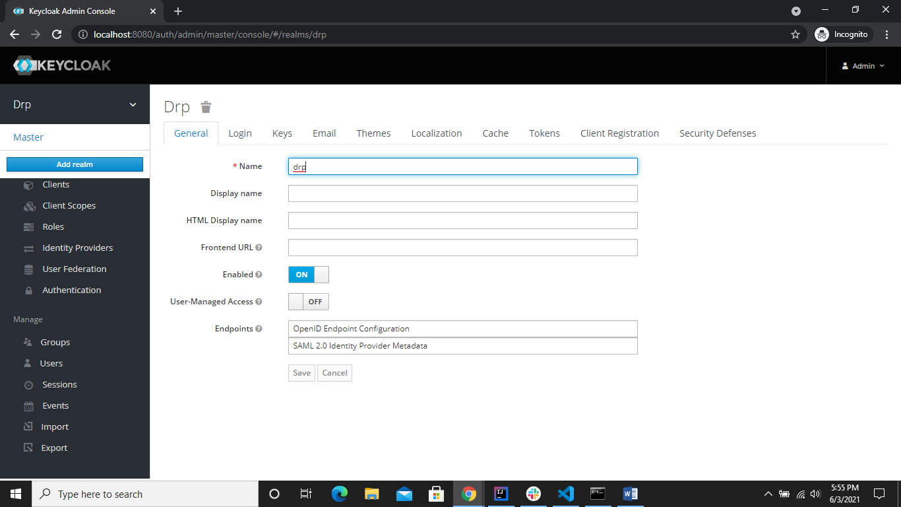

1. Create user for drp

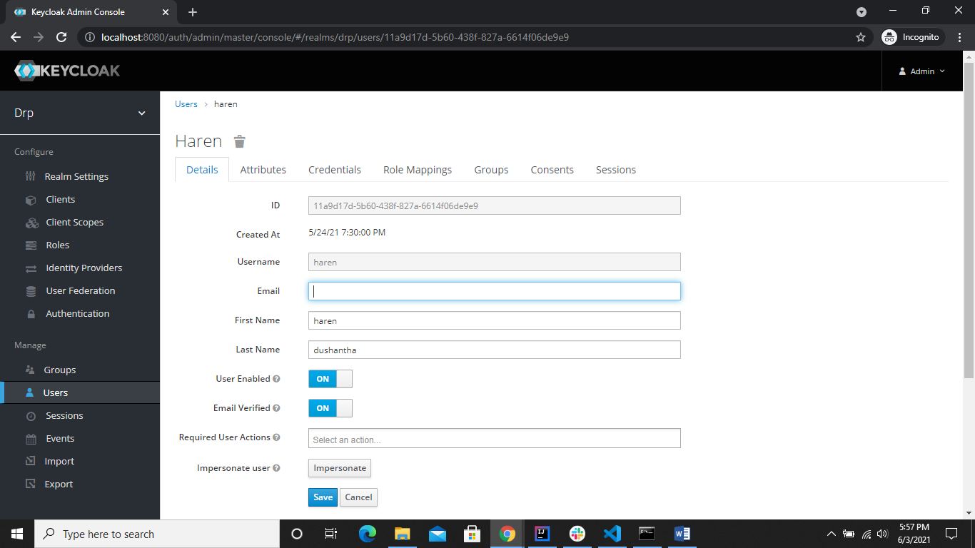

Set password for the user and check whether you can login or not. If you were unable to login to Keycloak unlock the user account/ update the password using below options.

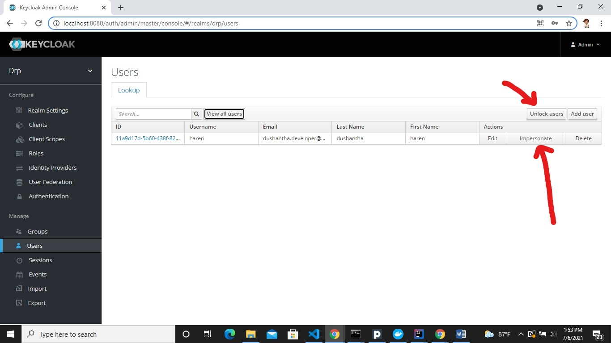

1. Register the client information

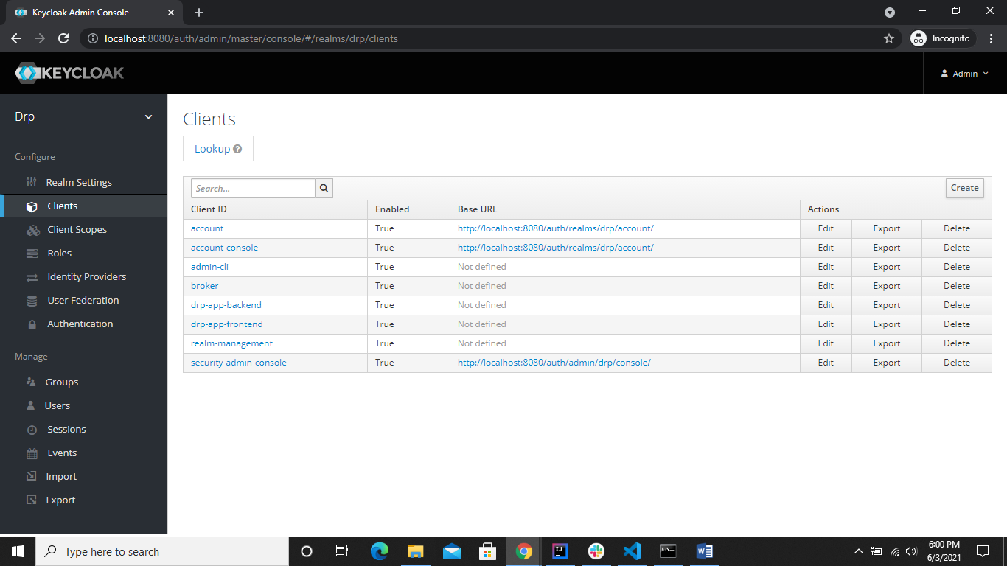

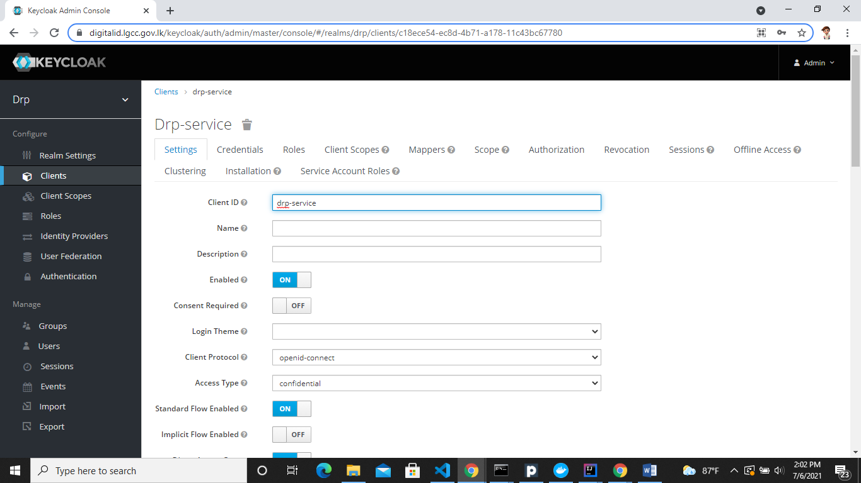

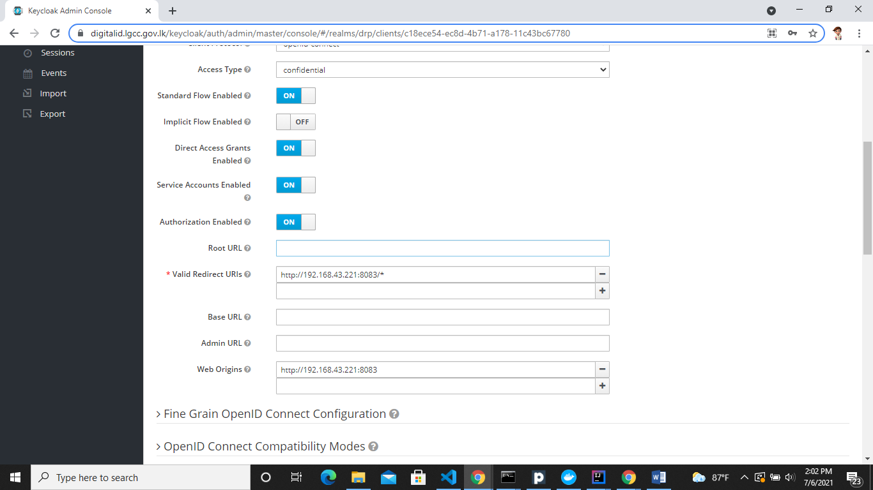

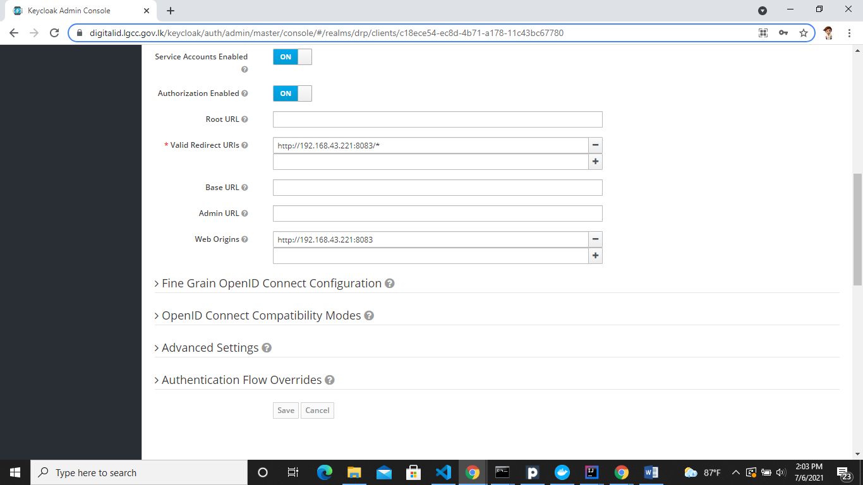

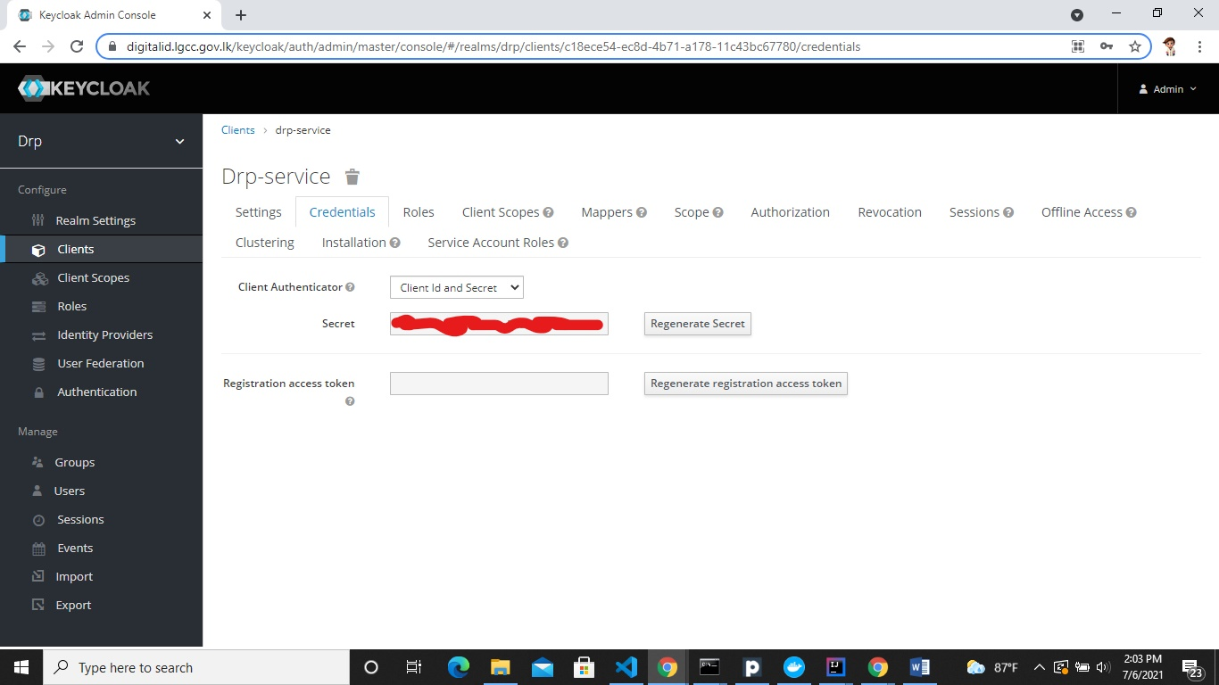

1. Create Roles for Drp realm and role mapping to user.

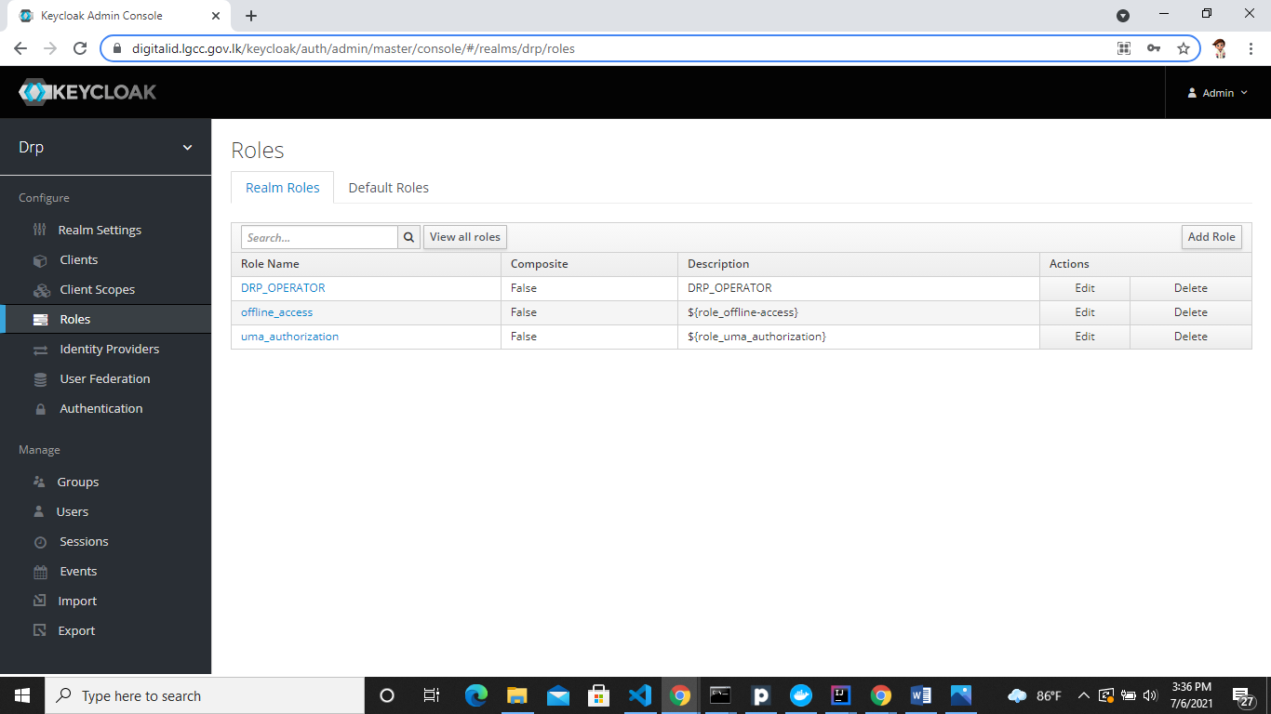

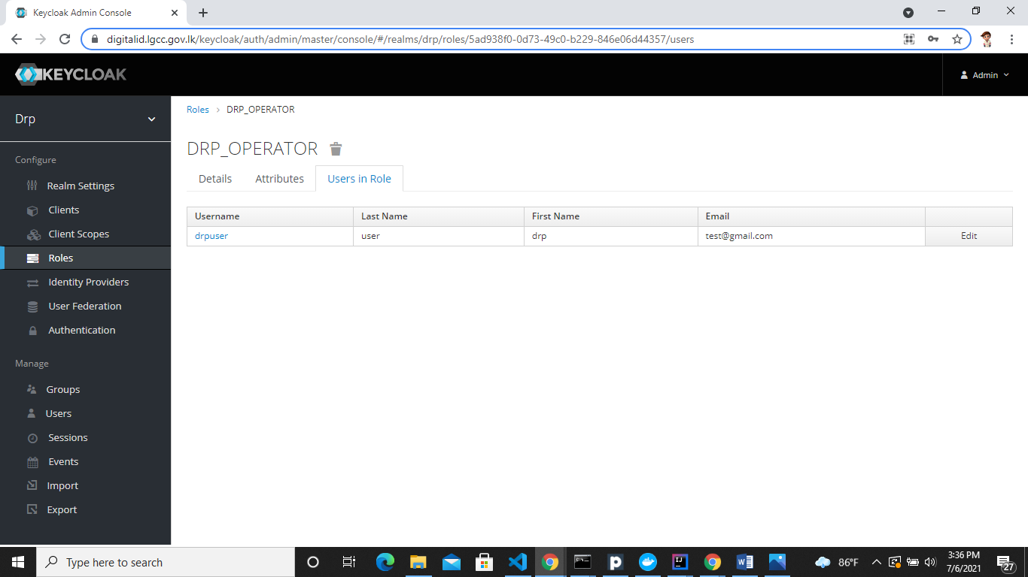

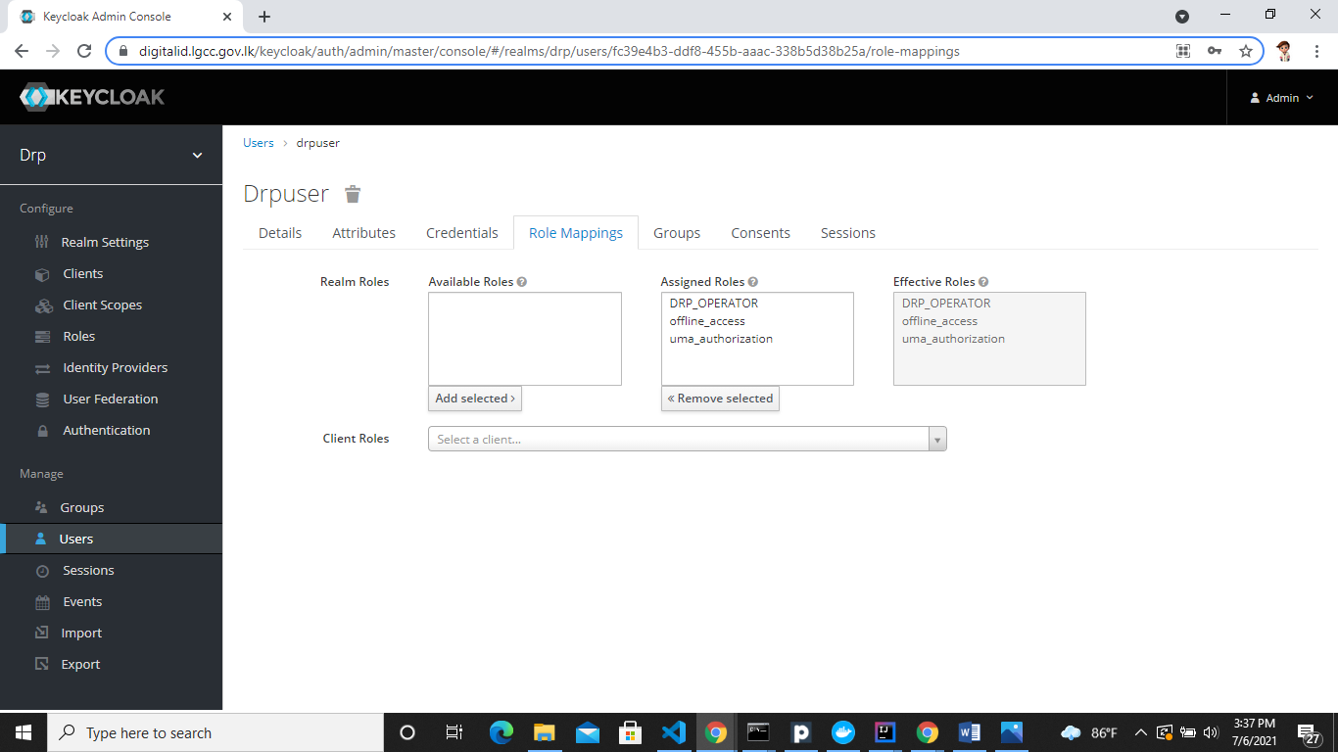

Point all the Keycloak endpoints to our local keycloak server in the application properties [drp-service backend].

1. Run drp-service backend

mvn clean install command or you can run intellij idea

**DRP – Keycloak Configuration [LGC2] Cloud Environment**

1. Create a New Realm as drp

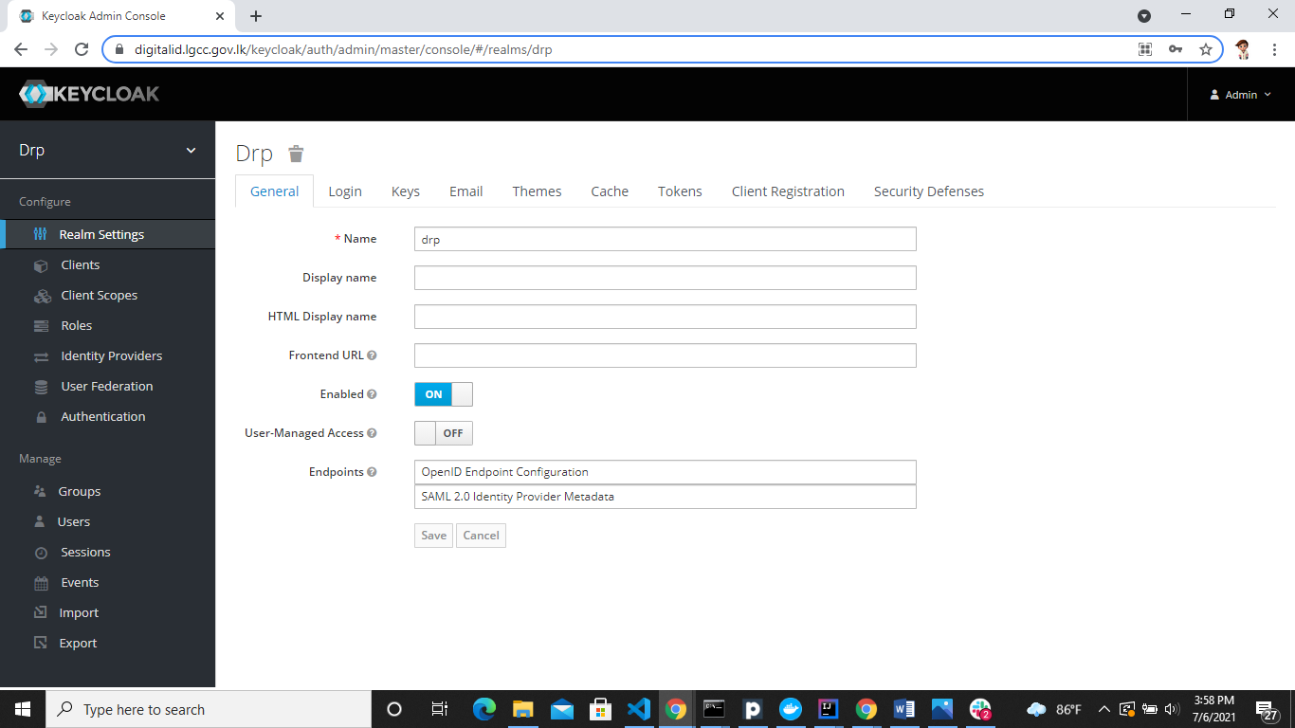

1. Create user for drp

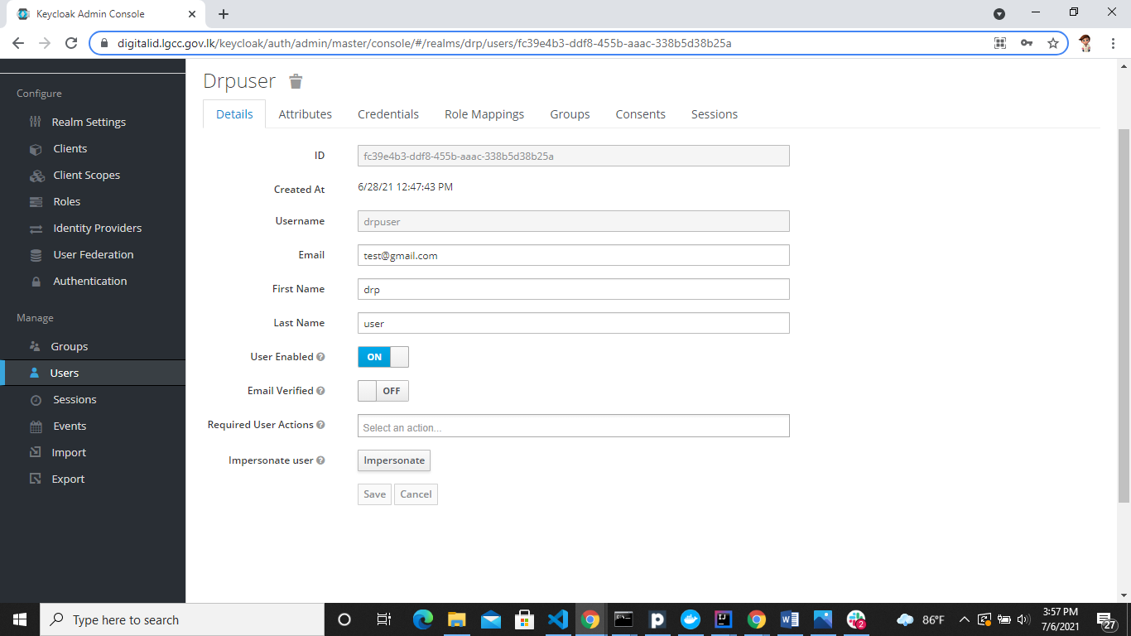

Set password for the user and check whether you can login or not. If you were unable to login to Keycloak unlock the user account/ update the password using below options.

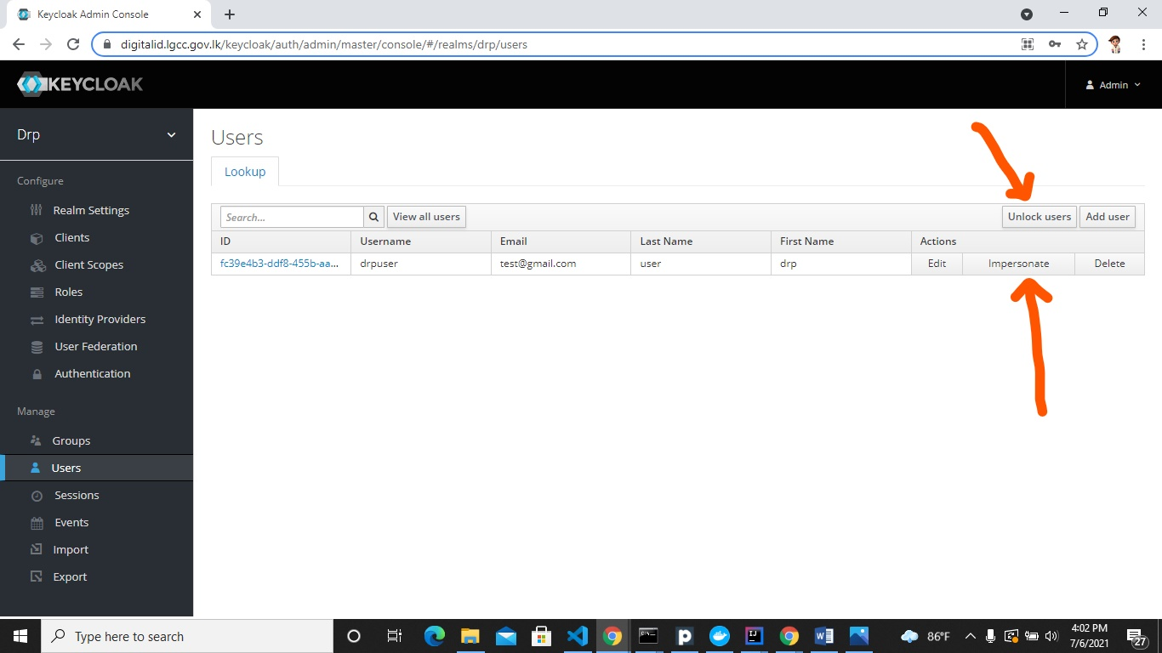

1. Register the client information











1. Create Roles for Drp realm and role mapping to user.







Point all the Keycloak endpoints to our Cloud environment[LGC2] in the application properties [drp-service backend].

1. Run drp-service backend

mvn clean install command or you can run intellij idea